**<Simple File Transfer using TCP>**

**Team12**

1. **Connect**



You have to enter “connect” with IP address and port number to connect with server..



You have to enter port number, when you implement server.

1. **Put**



When you connect with server, you can send file to server by entering “put” and file name.

1. **Get**

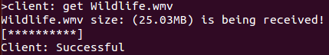

When you connect to server, you can receive file from server by entering “get” and file name.

1. **Control Send rate and receive rate**

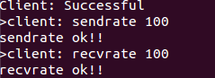

You can use keyword “sendrate” to control send rate and you can also use keyword “recvrate” to control receive rate.



If you enter “ratecurr”, you can confirm send rate and receive rate.

1. **Credit**



You can enter “credit” and student ID to see each member’s role.

1. **Close and quit**

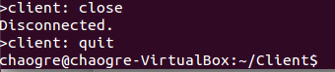

If you enter “close”, connection will be disconnected. You can use “quit” to finish the work.